Starting Bid $5,000

** Cannot be sold or used for any type of fire service capacity**

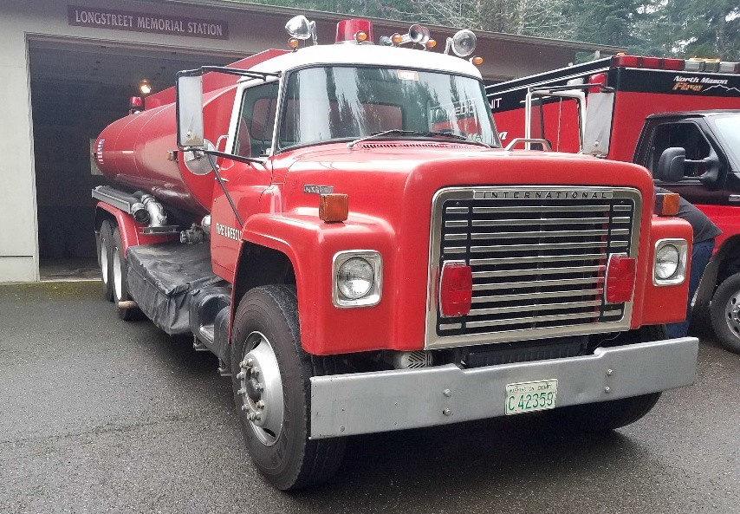
1975
INTERNATIONAL

Vehicle Specifications Manufacturer: International Make/Model: Loadstar VIN: 1D0712ECA24495
Year Built: 1975
Year of Purchase: 1975
Use: Tanker
Mileage: 28,233
Engine Hours: Unknown

Equipment Details GVW: 43,100 LBS
Vehicle Type: Heavy Truck

Doors: 2
Seats: 2
Airbags: None

Overall Length: 34’
Truck Height: 8’10’’
Wheelbase: 205
Tank Size: 3,000 GAL
Pump Capacity: 250 GPM

Engine & Performance Engine: Carbureted 6.4L V8
Engine Cylinders: 8 Cylinder
Transmission: Automatic 6-Speed Drive Type: 2WD Medium Duty Brake System Type: Air
Fuel Type: Gasoline

Miscellaneous
Includes Collapsible Water Tank
2022 DOT Inspection

